

**Business Plan**

**Noun-Verb Analysis**

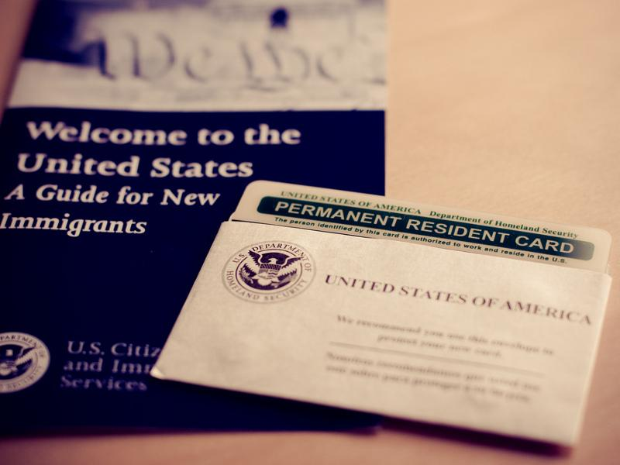

Team Members:

Bhavika Korat - 006704887

Mohammed Saad - 006712128

Zach McKellar - 003499495

Adam Ruppert - 005156004

Brandon Trussell - 005562826

Contents

[The Business Model 2](https://docs.google.com/document/d/1NGwyuHG6lOuNY1J1Df5CvjNWN3MJ_Zi8/edit#heading=h.gjdgxs)

[Business Concept 2](https://docs.google.com/document/d/1NGwyuHG6lOuNY1J1Df5CvjNWN3MJ_Zi8/edit#heading=h.30j0zll)

[Mission 2](https://docs.google.com/document/d/1NGwyuHG6lOuNY1J1Df5CvjNWN3MJ_Zi8/edit#heading=h.1fob9te)

[Vision 2](https://docs.google.com/document/d/1NGwyuHG6lOuNY1J1Df5CvjNWN3MJ_Zi8/edit#heading=h.3znysh7)

[Values 2](https://docs.google.com/document/d/1NGwyuHG6lOuNY1J1Df5CvjNWN3MJ_Zi8/edit#heading=h.2et92p0)

[SWOT 3](https://docs.google.com/document/d/1NGwyuHG6lOuNY1J1Df5CvjNWN3MJ_Zi8/edit#heading=h.tyjcwt)

[Business Capability 3](https://docs.google.com/document/d/1NGwyuHG6lOuNY1J1Df5CvjNWN3MJ_Zi8/edit#heading=h.3dy6vkm)

[Resources 3](https://docs.google.com/document/d/1NGwyuHG6lOuNY1J1Df5CvjNWN3MJ_Zi8/edit#heading=h.1t3h5sf)

[Strategic Partnerships 3](https://docs.google.com/document/d/1NGwyuHG6lOuNY1J1Df5CvjNWN3MJ_Zi8/edit#heading=h.4d34og8)

[Technology 4](https://docs.google.com/document/d/1NGwyuHG6lOuNY1J1Df5CvjNWN3MJ_Zi8/edit#heading=h.2s8eyo1)

[Business Value 4](https://docs.google.com/document/d/1NGwyuHG6lOuNY1J1Df5CvjNWN3MJ_Zi8/edit#heading=h.17dp8vu)

[Demonstrated Utility 4](https://docs.google.com/document/d/1NGwyuHG6lOuNY1J1Df5CvjNWN3MJ_Zi8/edit#heading=h.3rdcrjn)

[Demonstrated Trust 4](https://docs.google.com/document/d/1NGwyuHG6lOuNY1J1Df5CvjNWN3MJ_Zi8/edit#heading=h.26in1rg)

[Demonstrated Affordability 4](https://docs.google.com/document/d/1NGwyuHG6lOuNY1J1Df5CvjNWN3MJ_Zi8/edit#heading=h.lnxbz9)

[The Company’s Business 5](https://docs.google.com/document/d/1NGwyuHG6lOuNY1J1Df5CvjNWN3MJ_Zi8/edit#heading=h.35nkun2)

[Customer Segment 6](https://docs.google.com/document/d/1NGwyuHG6lOuNY1J1Df5CvjNWN3MJ_Zi8/edit#heading=h.1ksv4uv)

[Value Proposition 5](https://docs.google.com/document/d/1NGwyuHG6lOuNY1J1Df5CvjNWN3MJ_Zi8/edit#heading=h.44sinio)

[Delivery Channels 5](https://docs.google.com/document/d/1NGwyuHG6lOuNY1J1Df5CvjNWN3MJ_Zi8/edit#heading=h.2jxsxqh)

[Customer Relationships 5](https://docs.google.com/document/d/1NGwyuHG6lOuNY1J1Df5CvjNWN3MJ_Zi8/edit#heading=h.z337ya)

[Revenue Streams 5](https://docs.google.com/document/d/1NGwyuHG6lOuNY1J1Df5CvjNWN3MJ_Zi8/edit#heading=h.3j2qqm3)

[Key Resources 5](https://docs.google.com/document/d/1NGwyuHG6lOuNY1J1Df5CvjNWN3MJ_Zi8/edit#heading=h.1y810tw)

[Key Activities 5](https://docs.google.com/document/d/1NGwyuHG6lOuNY1J1Df5CvjNWN3MJ_Zi8/edit#heading=h.4i7ojhp)

**The Business Model**

**Mission:**

Our mission is to establish a process for listed Visas (**F1 Visa, H1 Visa, B1 Visa**) to easily apply for a US Green Card. The current system is compartmentalized and does not allow for easily transferable of **application** and information of an existing Visa holder. We want to make the process of gaining a Green Card simple for those who have already been approved for listed Visas.

**Vision:**

We will establish a digital system that will allow for existing listed Visa holders to apply for a Green Card while they are a Visa card holder. At the moment the wait times are extremely long to gain a US **Green Card**. Many people who have applied and gained a Visa still have no simple path to become a citizenship. They have passed all legal requirements to enter the country, has spent time within the country, and in many times want to apply for a Green Card. These two processes do not communicate and extend  the process of gaining citizenship.

With our system established we will improve communication between departments, allowing individuals to gain citizenship quicker. When these systems do not communicate it leads to redundant work for both departments tying up resources. With more fluid communication the information about an **applicant** can be simply passed along. This will allow an applicant to have a single file instead of two, one for Visa and one for Green Card.

**Value:**

* We are looking forward to provide a better solution for the Green Card applicants by reducing the wait time for their application process.
* In the meantime, we are also trying to inculcate the data integrity in the application process, so that the **applicants** data is safe.
* We are looking forward to dynamically update the customer information on the system, so that the process takes lesser time than usual.

**SWOT**

|  |  |
| --- | --- |
| Strength:   * Easily Apply for Green Card * Digitizing forms  speed up process * Forms automatically move to the next process * Easily implemented with other visa processes | Weakness:   * Expensive to implement * Needs to be robust * Needs to be multilingual * Inexperienced User to digital interface * Constant maintenance |
| Opportunities:   * Can be implemented in other locations * Offers incentive to become educated in US * Offers incentive for people to start businesses | Threats:   * Limited green cards handed out * Unconstant power supplies within the country * Not a steady connection to the main servers in US * Change in government politics |

**Business Capability**

**Resources:**

The main resources that will be utilized is an information system website. It will need to collect personal information on an applicant. The system must be in the native language and simply understood by those who are not familiar with the application process. The software should allow for payment to be made within. The application should also allow it to be saved offline incase of lost connection.

Other resources will be the employees working on the system! Our team has first hand experience with the Visa (**F1 Visa, H1 Visa, B1 Visa**) and Green Card process. We have taken what we have learned through the process and applied it to the system. We also have talented software engineers that will develop and maintain the system. With how powerful software has become we are confident we have created a more streamlined process that will help both those who applied and those who work on those **applications**.

**Strategic Partnerships:**

There are two strategic partnerships, The US Visa department and **US Green Card department**. At this time, when a Visa applicant wishes to apply for a Green Card they must start the process over. We will look at what both departments and identify what is similar between the processes. From there we will digitize what part of the process is similar so that this information can be simply passed along to the next step in the process.

The country in which the software is implemented will also be partnered with. We will understand the culture and customize the user interface to make the process user friendly.

**Sponsoring Businesse**s will be another strategic partner. A business will need to sponsor an applicant for the application to be completed. These partners will be approached and chosen the applicant. The **sponsoring business** will play a key role in the applicants staying. They will offer an indefinite job to the applicant which will allow them to start a new life.

Another wonderful partnership will be with the **card processing company.** These companies will allow the easy integration of all foregin currency to pay for the application. The card processing companies will

**Technology:**

We will use the cloud to facilitate the application and to back up the application. This will allow for maximum robustness and to be fault tolerant. The application will be able to be downloaded and to be completed offline. This will allow those who do not have a steady connection the ability to fill the form out without the issues of disconnecting.

Since we are handling sensitive data  all channels between the applicant and the servers will be encrypted.  The system should allow for two factor authentication on the applicant side to protect the personal data of the applicant.

**Business Value**

**Demonstrated Utility**

We are looking forward to reduce the wait time for the customers (applicants) who apply for a United States Green Card. Government in collaboration with the embassy of the applicants country can fasten the process of visa for **F1 Visa, H1 Visa, B1 Visa** . The creamy layer of the applicant pool can be given importance, and taken into consideration first. Thus, making the process easier for both the applicants and the government.

**Demonstrated Trust**

The system will look forward to establish trust among both the parties by having the authentic and proper data analyzed and stored periodically. Also, maintaining the applicant’s data integrity and preventing any kind of risk associated with the data and ensure the security of data.

**Demonstrated Affordability**

The system will offer a better service with **card payment**. As the current system has only one type of payment available. We will look forward to inculcate better solutions for this to make it easier for the customers to apply on proper time and not worry about the **payment method**. Based on different payment options, customers can get varied services.

**The Company’s Business**

**Consumer Segment**

Our consumers are individuals of all ages who are looking for a pathway to citizenship within the United States. These consumers range from various different ethnic, cultural, political, economic, and religious backgrounds around the world and are seeking a new opportunity.

**Value Proposition**

**Immigration Services** is committed to providing an efficient and fair immigration process to the many individuals around the world seeking a pathway to U.S. citizenship.

**Delivery Channels**

Application services to apply for a green card will be primarily handled through electronic services through our federal domain. Applicants will need access to a computer and a stable internet connection in order to connect to our servers and to fill out the forms. For those individuals who do not have access to a computer, they can mail documents to, or visit one of our offices in order to complete the application process. Individuals wishing to mail documents should expect delayed service times for shipping.

**Customer Relationships**

Immigration services strives to ensure that each applicant is treated fairly and respectfully. Our offices are staffed with numerous **employees** who speak a wide variety of languages and are able to assist individuals of different backgrounds around the world.

**Revenue Streams**

**Immigration services** is federally funded through grants and application fees.

**Key Resources**

Equipment, database, tools, labor, manpower,

**Key Activities**

Data storage, data transfer, data protection, **application** processing, background checks